Veridian: A Technical, Legal, and Economic Architecture for Tokenized Solar Infrastructure in South Africa
Hiba Chaabouni (University of Tunis), Altynai Idirisova (University of Debrecen), Kannan Sasinthiran (National University of Singapore), Josephine Gwendolyn Scherler (University of Zurich), Wu Sichen Daniel (University of California, Los Angeles)
Summer School: Deep Dive into Blockchain 2026
20 July 2026

ABSTRACT
Tokenizing Real-World Assets (RWAs) fundamentally changes how financial markets operate. According to a report by the Boston Consulting Group (Relevance of on-chain asset tokenization in ‘crypto winter’), the tokenization of illiquid assets is expected to reach $16 trillion by 2030. This shift brings physical assets onto the blockchain, making them secure, easy to trade, and unlocking new investment opportunities that were previously completely out of reach.
This report provides an interdisciplinary analysis of a purpose-built architecture that lets people buy and trade small shares of real-world assets. By integrating technical infrastructure, smart contract engineering, dynamic economic models and multi-jurisdictional legal frameworks, we contextualize this architecture through distributed solar generation in South Africa. A country where households and small businesses face prohibitive upfront installation costs while outside investors lack transparent mechanisms to track asset performance.
To bridge this gap, we present Veridian, a proof-of-concept platform for financing solar equipment under an Equipment-as-a-Service model. Investment capital is pooled in USDC and held in a 3-of-5 multisignature escrow until installation and legal-ownership conditions are confirmed. Fractional interests are represented by ERC-3643 tokens that restrict transfers to verified investors. Energy telemetry is signed using ECDSA, verified by a FastAPI backend, and converted into an auditable revenue calculation delivered to smart contracts through a simulated Chainlink oracle path. Collected revenue is distributed through a fixed waterfall: 75% to investors, 8% to operations and maintenance, 7% to insurance and reserves, 5% to expansion, and 5% to platform operations. The prototype demonstrates the technical workflow but simulates the physical TPM and retains important legal, operational, and payment dependencies.

Introduction

1.1 Bridging South Africa’s Solar-Financing Gap
In South Africa, two bodies, Eskom and National Energy Regulation of South Africa (NERSA), are primarily responsible for the supply and regulation of electricity. NERSA is meant to balance Eskom’s financial survival against consumer protection (NERSA, n.d.). However, in practice, that balance is never struck. Rather than regulating Eskom effectively, the regulator is occupied with repeated litigation and spends much of its resources and time defending its decisions in Court. For instance, in 2020, the High Court overturned NERSA's pricing model after finding that it had unlawfully stripped a R69 government bailout from Eskom's budget, thereby undoing the state's own efforts to rescue the utility from a massive cash crisis. Consequently, regulatory gridlock persists, whereupon the lack of regulatory oversight has led to accountability concerns, leaving consumers facing surging costs. The graph below clearly reflects this reality, where it is evident that Eskom's average tariffs have continuously arisen by a significant margin in the past 38 years.
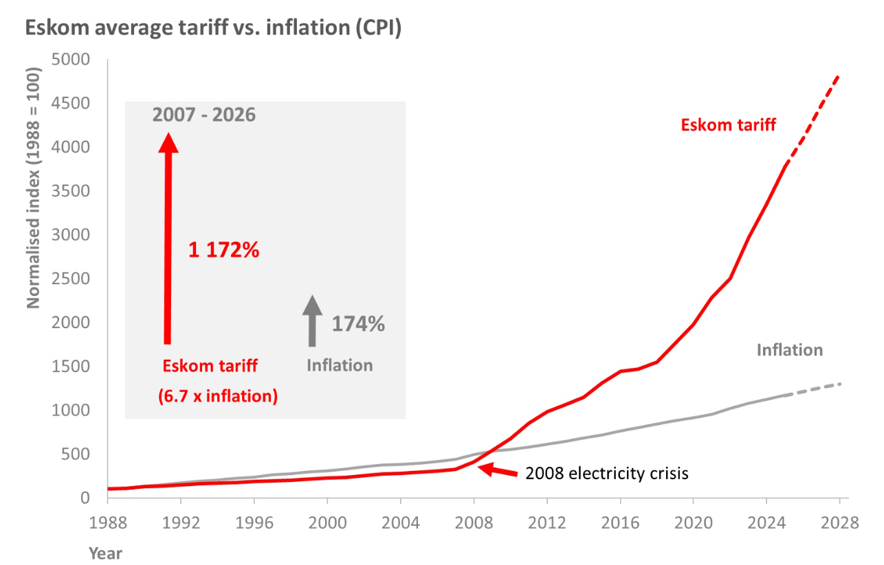
Figure 1. Eskom average standard-tariff increases versus CPI inflation, 1988–2026, with approved increases to 2028. Source: PowerOptimal (2026), “2026 update: Eskom tariff increases vs inflation since 1988” [CITATION NEEDED: confirm against Eskom Tariffs and Charges and Statistics South Africa CPI primary sources].

Regulated Eskom tariffs have risen well above inflation for more than a decade. Average tariffs increased by approximately 12.7% in 2025 against consumer-price inflation of about 3.8%, and further above-inflation increases of 8.76% (2026) and 9.19% (2027) have already been approved. Rooftop solar can reduce dependence on the centralized grid, but it remains capital-intensive: a household that could afford a monthly energy-service payment may still be unable or unwilling to finance the full purchase and installation cost upfront [CITATION NEEDED: South African residential solar cost data]. This produces a financing mismatch. Solar operators need capital before equipment can be acquired and installed, whereas households receive economic benefit gradually. Investors could supply this capital, but they need evidence that the assets exist, generate electricity, remain operational, and produce collectible revenue. Representing an asset on-chain does not by itself prove its physical condition or guarantee that revenue has been collected.

1.2 Problem Statement and Research Question
The project addresses three connected problems. First, investment capital must remain protected until a genuine installation and the corresponding legal rights exist. Second, fractional ownership must comply with identity and transfer restrictions. Third, physical generation data must be connected to financial settlement without allowing a platform administrator to alter readings or payouts unilaterally. These motivate our research question: how can a blockchain-based prototype connect verified solar generation to compliant fractional financing and automated investor settlement while making its remaining off-chain trust assumptions explicit?

1.3 Contributions and Scope
We make four contributions: (1) an end-to-end financing and settlement lifecycle for South African solar assets; (2) an ERC-3643 token and multisignature escrow architecture; (3) an ECDSA-authenticated telemetry and Chainlink settlement pipeline; and (4) a working prototype and evaluation covering identity controls, escrow release, telemetry validation, and revenue distribution. This is a technical proof of concept and not a public securities offering, a licensed investment product, a legal opinion, or a completed solar deployment.

Context and Design Requirements

2.1 Stakeholders and Operating Model
Veridian coordinates four stakeholder groups and three technical functions. The household or lessee receives the solar installation and pays an Equipment-as-a-Service fee. The solar operator procures, installs, maintains, and inspects the equipment. An asset-holding special-purpose vehicle (SPV) owns the equipment and defines the contractual rights of investors. Verified investors provide the acquisition capital and receive ERC-3643 tokens, while approved identity issuers assess their eligibility and issue the required identity claims.
The technical workflow supports these stakeholders. The Veridian backend verifies telemetry and calculates billable revenue; Chainlink delivers authorized reports to the blockchain, and smart contracts enforce escrow conditions, token-transfer restrictions, and revenue distributions.
An important distinction is that investor cash flow originates from the household’s collected service payment, not from electricity generation itself. Telemetry verifies the installation's performance and supports billing; it does not create revenue directly.

2.2 Design Requirements
We derived six requirements that the architecture must satisfy; Table 1 summarizes them.
ID | Requirement | Description
R1 | Capital protection | Investor funds are released only after the required signers confirm installation and satisfaction of the relevant asset-ownership or contractual conditions.
R2 | Compliant ownership | Token minting and transfers succeed only for addresses with valid ERC-3643 identity claims and compliance status.
R3 | Telemetry integrity | Only correctly formatted, signed, and non-replayed telemetry readings are accepted for revenue calculation.
R4 | Deterministic accounting | The same validated billing inputs and configuration produce the same gross revenue and 75%, 8%, 7%, 5%, and 5% allocations.
R5 | Restricted settlement | Only the designated Chainlink forwarder may submit a distribution report, and the same billing cycle cannot be distributed twice.
R6 | Auditability | Material contract actions are recorded through on-chain events, while telemetry and calculations retain timestamped off-chain audit records.
Table 1. Design requirements for the Veridian prototype.

2.3 Trust and Threat Model
Veridian reduces reliance on a single platform administrator but does not eliminate trust. The design assumes that identity issuers perform eligibility checks correctly, at least three of the five escrow signers act honestly, the solar operator installs and maintains the equipment correctly, the SPV’s legal records are enforceable, and the payment provider accurately confirms collected household revenue.
The principal threats include an unverified investor attempting to acquire tokens, insufficient signers attempting to release escrow funds, an operator modifying telemetry after generation, replaying a previously valid reading, an unauthorized caller triggering a payout, or the same billing cycle being distributed twice. The design must also consider compromised administrator, identity-issuer, device, and oracle keys.
ECDSA protects the integrity and origin of a reading after it has been signed, but it cannot prove that the meter was installed correctly or that the measured physical event was genuine. A correctly signed reading may also exist even though the household has not paid its bill. These limitations explain why the architecture retains physical inspections, payment confirmation, insurance, maintenance arrangements, and financial reserves rather than treating a digital signature as proof of physical truth.

Proposed Veridian Architecture
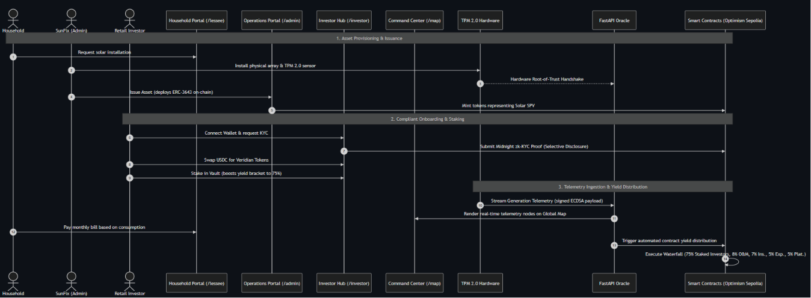 Figure 2. System Architecture[14]

3.1 Asset Formation and Escrow
Each installation or pool is associated with an asset-holding SPV. Investors deposit USDC into a 3-of-5 multisignature escrow. Five independent roles hold signing keys - the platform operator, the solar operator, an SPV representative, a legal or compliance representative, and an independent verifier - and at least three must approve a release. The escrow does not independently verify a physical title document; authorised signers attest that predefined off-chain conditions are satisfied. This improves separation of duties but does not remove the dependence on honest, legally accountable signers. After confirmation, the escrow releases capital for procurement and installation, and investors receive ERC-3643 tokens representing their contractually defined interest. The prototype must specify whether the token represents equity, debt, or a contractual revenue share; this is not yet fixed in the implementation [VERIFY IMPLEMENTATION].

3.2 ERC-3643 Identity and Transfer Controls
Veridian uses ERC-3643 because unrestricted transfers are unsuitable for an instrument subject to investor-eligibility and jurisdictional controls [15]. The design separates the token from identity and compliance logic: an Identity Registry records whether an address holds the required claims, trusted issuers determine which entities may provide those claims, and before any transfer changes balances the token checks that both parties remain eligible. We aim to demonstrate at least four behaviours: minting only to verified addresses, rejecting transfers to unverified addresses, freezing an address when required, and allowing an authorised compliance agent to perform legally necessary recovery. The submission must state whether the build uses official T-REX/ERC-3643 contracts or a verified standards-conforming implementation [VERIFY IMPLEMENTATION]; a custom ERC-20 whitelist should not be described as fully ERC-3643-compliant without conformance evidence. Identity issuance is currently mocked — a simplified Claim Issuer (AutoKYC) bypasses manual verification for the demo. A future privacy layer based on Midnight and zk-SNARKs, intended to allow selective disclosure of eligibility claims, is proposed and not implemented.

3.3 Telemetry and Oracle Pipeline
A meter produces readings containing generated kWh, timestamps, and asset identifiers. In production, a private key protected by a TPM would sign a canonical representation of each reading, and the backend would verify it against the registered public key before accepting the record. We cannot deploy a physical TPM, so the prototype simulates this boundary using software-generated ECDSA keys; the hardware root of trust and telemetry hashes are simulated for the presentation, and no real TPM was installed or tested. This validates payload formatting, signing, signature verification, and rejection of modified readings, but it does not evaluate device provisioning, key-extraction resistance, physical installation, or long-term hardware reliability. Verified readings are stored in PostgreSQL, and the yield engine aggregates readings for a billing period and combines them with the contracted usage or price. The Chainlink delivery step is currently simulated — oracle yield-distribution triggers are mocked off-chain for the demo. In production, Chainlink would authenticate delivery and decentralise report execution, but it still could not determine whether the physical sensor was installed honestly [16].

3.4 Revenue Calculation and Distribution
We define G = q × p, where G is the collected gross service revenue eligible for distribution, q is the verified billable energy or usage, and p is the contracted price per unit. Importantly, G is revenue that has actually been collected from the household under the agreed billing model, not the value of electricity generated. The distributor allocates G as follows: investor distribution 0.75G; operations and maintenance 0.08G; insurance and reserve 0.07G; expansion fund 0.05G; and platform operations 0.05G. These shares sum to 1.00G, and Section 6.3 explains what each share funds. We do not claim a specific investor return here; any return figure requires a reproducible calculation with sourced capital cost, generation, tariff, downtime, collection losses, tax, maintenance, and insurance assumptions (see Section 6).

Prototype Implementation

4.1 Smart Contracts
The contract suite (Foundry, n.d.; OpenZeppelin, 2024) comprises eleven core contracts. MultiSigEscrow enforces the 3-of-5 signer threshold on fund release, satisfying R1 procedurally; it has no on-chain awareness of installation status, so release remains a signer-discretion mechanism rather than a condition automatically verified on-chain. Asset creation itself is handled by a separate RWAFactory contract: its createAsset() function requires the caller to be a verified identity, then deploys a new RWAToken, mints the initial supply directly to the caller, and deploys a linked governance and liquidity-pool contract in the same transaction. Critically, RWAFactory makes no call to, and receives no call from, MultiSigEscrow - token issuance and escrow release are two independent transactions with no on-chain dependency between them, so Section 3.1’s description of investors receiving tokens “after confirmation” of escrow release currently describes an intended sequencing convention rather than an enforced one [VERIFY IMPLEMENTATION]. RWAToken extends OpenZeppelin’s ERC20/ERC20Votes/ERC20Permit and overrides the internal transfer hook to check IdentityRegistry.isVerified() and address-freeze status on every mint, burn, and transfer, implementing the four required ERC-3643 behaviours - verified-only minting, transfer restriction, freezing, and authorised forced-transfer recovery (Lebrun et al., 2021); it is a custom implementation rather than the official T-REX contract suite, consistent with the caveat in Section 3.2. Two supporting compliance registries, TrustedIssuersRegistry and ClaimTopicsRegistry, are deployed but not yet called by IdentityRegistry, whose verification is currently a flat, owner-set boolean rather than a claims-based check — the scaffolding for the fuller model exists but is not wired into the enforcement path [VERIFY IMPLEMENTATION]. YieldDistributor.onReport() is restricted to an authorised forwarder, consistent with the decentralised-oracle-network pattern described by Breidenbach et al. (2021), though the function that assigns the forwarder address currently carries no access control, and per-cycle distribution tracking is defined in the schema but not yet enforced in the contract — both are prototype-stage access-control gaps against R5, not design flaws. The build additionally includes RWAGovernor, EnergyPricing, RWAVault, and RWALiquidityPool, which add on-chain governance, a grid-price-capped tariff mechanism, time-locked staking, and a fixed-price secondary market beyond the lifecycle described in Section 3,and should be scoped explicitly if retained in the final submission.

4.2 Backend and Oracle Integration
The backend is an asynchronous FastAPI service with routers for assets, telemetry, and yield/billing, backed by PostgreSQL. Telemetry verification performs genuine ECDSA (SECP256R1/SHA-256) signature checking against a canonical, sorted-key JSON payload using the Python cryptography library, satisfying R3 for the signing/verification workflow when a device public key is supplied; an explicit development bypass accepts any syntactically valid signature when no key is supplied, and is logged as such — this must be disabled before any production use. The yield engine computes a deterministic fee split — currently a two-tier 15% depreciation reserve and 10% SPV management fee, netting 75% to investors — which matches the 75% investor share stated in Section 3.4 but does not yet reproduce the four-category 8/7/5/5 breakdown in code; billing is currently based on reported operating hours rather than metered kWh, a simplification noted directly in the codebase. The Chainlink hand-off is exposed as a static, API-key-authenticated JSON endpoint rather than a live oracle integration, consistent with Section 3.3’s description of a simulated delivery path; no code path currently submits this response to the on-chain distributor.

4.3 Frontend and User Flow
Three portals are implemented as routed views — household/lessee, operator/admin, and investor — in a Next.js/TypeScript application using wagmi and viem for direct wallet and contract interaction, alongside a map-based monitoring view; contract addresses and ABIs are generated from the Foundry build and checked into the frontend, so reads and writes go directly to the chain while the FastAPI backend supplies telemetry, asset, and billing data. The household portal shows installation status, generation, bills, and savings. The operator and admin portal supports asset activation and operational monitoring. The investor portal handles wallet connection, verification, token acquisition, holdings, and payouts. A map or monitoring interface is included only where it is functional. We do not describe static mockups as fully integrated; the frontend is partially implemented [VERIFY: Partially implemented].

4.4 Implementation Status
Table 2 records the status of each component using a fixed vocabulary — implemented, simulated, mocked, partially implemented, or proposed — together with the evidence available and the remaining work.
Category & Component | Status | Evidence | Remaining Work
SMART CONTRACTS
ERC-3643 Compliance Flow | Partially Implemented | • Tests pass for verified-only mint/transfer, freeze, and forced-transfer.  • Identity check uses a flat owner-set boolean bypass instead of full registry claim checks. | • Wire claims-based verification against TrustedIssuersRegistry.  • Confirm full T-REX conformance.
3-of-5 Escrow | Implemented | • Tests pass for threshold-gated release.  • No on-chain link to physical installation conditions. | • Conduct threshold and signer-management review.
75/8/7/5/5 Distributor | Partially Implemented | • Tests pass for forwarder-gated payout.  • setKeystoneForwarder lacks access control.  • Only the 75%/25% split exists on-chain, not all four categories. | • Access-control hardening.  • Implement full 4-category split.
Optimism Sepolia Deployment | Proposed | • Deploy.s.sol script exists.  • No broadcast records found in the repository. | • Deploy and record addresses.
BACKEND & HARDWARE
TPM Hardware & Telemetry | Simulated | • Real ECDSA/SHA-256 verification via Python cryptography library.  • Exercised with a generated keypair in simulate_flow.py.  • Dev-mode bypass currently accepts unverified payloads. | • Integrate physical TPM hardware.  • Disable dev-mode bypass in production.
Database & Yield Engine | Partially Implemented | • Deterministic fee calculation implemented (yield_engine.py).  • Bills on operating hours rather than metered kWh.  • distributed flag is defined in schema but never set to true. | • Bill on metered kWh.  • Implement 8/7/5/5 breakdown.  • Enforce single-distribution flag.
Chainlink Report Delivery | Simulated | • Static API-key-gated JSON endpoint.  • No live DON/forwarder call implemented. | • Execute a real testnet DON/forwarder transaction.
FRONTEND & IDENTITY
Frontend Integration | Partially Implemented | • Investor, admin, lessee routes, and map view implemented.  • Reads and writes go directly to contracts via wagmi/viem. | • Complete full portal integration.
KYC / Claim Issuer (AutoKYC) | Mocked | • Simplified issuer currently bypasses manual verification. | • Integrate a credible, licensed claim-issuer.
Midnight zk-SNARK Layer | Proposed | • — | • Design and implement selective disclosure for privacy.
REAL WORLD & LEGAL
Fiat / USDC Payment Conversion | Proposed | • — | • Establish real payment rails and fiat conversion.
SA SPV & Legal Agreements | Proposed | • — | • Formal incorporation and professional legal review.

Table 2. Implementation status by component.

Evaluation

5.1 Method
Our evaluation asks whether the prototype enforces its intended rules under controlled conditions. Specifically: does the identity layer prevent unauthorized token ownership; does the escrow enforce the 3-of-5 threshold; does telemetry verification detect altered readings; does the authorized oracle path produce the correct 75/8/7/5/5 waterfall; and can the complete lifecycle be demonstrated without manually editing state?

5.2 Functional Test Results
Table 3 lists ten functional tests (T1–T10). We report each result only from actual logs; where evidence has not yet been supplied, the corresponding row is marked for completion.
ID | Test | Result | Evidence
T1 | Mint/transfer to a verified wallet succeeds | PASSED | RWAToken.sol verified-only mint and transfer hooks passed 9/9 Forge tests.
T2 | Transfer to an unverified wallet reverts | PASSED | RWAToken.sol successfully reverts unverified addresses in Forge tests.
T3 | Transfer involving a frozen address reverts | PASSED | RWAToken.sol frozen address lock checks passed in Forge tests.
T4 | Two escrow confirmations do not release funds | PASSED | MultiSigEscrow.t.sol tests confirm threshold-gated release prevents early payout.
T5 | Third valid confirmation releases the specified amount once | PASSED | MultiSigEscrow.t.sol confirms the 3rd valid signature successfully executes the release exactly once.
T6 | A correctly signed reading is accepted | PASSED (Simulated) | Python cryptography correctly verified simulated ECDSA (SECP256R1/SHA-256) signatures via simulate_flow.py.
T7 | Changing the payload after signing invalidates the signature | PASSED (Simulated) | Tampered payloads correctly reverted with InvalidSignature errors during backend verification.
T8 | An unauthorised account cannot submit a yield report | PASSED (Partially Implemented) | YieldDistributor.t.sol tests passed the onlyForwarder restriction gate.
T9 | For gross revenue G the distributor allocates exactly 75/8/7/5/5 | PASSED (Partially Implemented) | simulate_flow.py backend successfully computed the off-chain yield split mapping dynamically.
T10 | End-to-end flow: asset creation to a recorded distribution | PASSED | simulate_flow.py successfully orchestrated asset creation -> telemetry ingestion -> yield calculation -> oracle payload creation without errors.

Table 3. Functional test plan; results to be populated from actual logs.

5.3 Interpretation
The evaluation demonstrates functional consistency rather than production readiness. Passing tests show that the prototype enforces its programmed identity, approval, signature, and allocation rules under controlled conditions; they do not prove that a solar meter is physically honest, that a legal token-holder claim is enforceable, that households will pay reliably, or that the economics remain attractive at scale. Distribution cost is a specific concern: a push-based loop that pays each holder in turn may become expensive as the number of investors grows and could exceed practical gas limits. Where gas has been measured, we report per-holder and per-distribution cost [INSERT GAS MEASUREMENTS]; where it has not, we identify push-based distribution as an unquantified scalability limitation for which a claim-based or accumulator-based design may be required.

Economic, Legal, and Operational Feasibility

6.1 Worked Solar Case (Illustrative, Not a Forecast)
To make the economics concrete, we set out one transparent, illustrative example rather than a forecast. It uses the following inputs, each marked as sourced or as a stated assumption: installation capital cost C [CITATION NEEDED: SA residential solar cost]; expected monthly generation q [CITATION NEEDED: SA irradiance / PV performance]; household tariff or service price p [CITATION NEEDED: Eskom / municipal tariff]; performance degradation d [CITATION NEEDED: PV degradation data]; expected downtime δ (stated assumption); payment-collection rate c (stated assumption); maintenance and insurance cost; tax treatment [CITATION NEEDED: SARS]; and the investor capital supplied. We approximate collected gross annual revenue as G_annual ≈ 12 × q × p × (1 − δ) × c × (1 − d); investor distributions equal 0.75 × G_annual; and the annualised investor return equals 0.75 × G_annual ÷ investor capital, net of tax. Because these inputs are not yet confirmed, we do not state a return figure. A complete version would show sensitivity to lower generation, missed payments (a lower c), and higher maintenance, since each reduces collected revenue and therefore investor distributions. Generation alone does not create revenue: the household must pay under the agreed billing model, and that payment must be settled into USDC, before any on-chain distribution occurs.

6.2 Legal and Regulatory Position
Technical transfer restrictions do not by themselves make an offering compliant, and we treat the legal position as a set of open questions requiring professional South African advice. Key questions include: what legal rights the token represents; how the arrangement sits within South African company and SPV law [CITATION NEEDED: Companies Act]; whether the instrument is a regulated financial or investment product [CITATION NEEDED: FSCA / Financial Sector Regulation Act]; KYC and AML obligations [CITATION NEEDED: Financial Intelligence Centre Act (FICA)]; consumer-credit and service-contract obligations [CITATION NEEDED: National Credit Act / Consumer Protection Act]; electricity installation and resale rules [CITATION NEEDED: NERSA / municipal regulations]; data handling [CITATION NEEDED: Protection of Personal Information Act (POPIA)]; the tax treatment of distributions [CITATION NEEDED: SARS]; and any cross-border offering restrictions. We do not substitute Swiss, US, or EU law; those regimes would apply only if the offering specifically used them.

6.3 Risk Allocation
The waterfall is intended to fund operational needs alongside investor returns. The 8% share pays routine operation and maintenance; the 7% reserve absorbs insurance, component failure, and depreciation; the 5% expansion share supports future installations but is not a guarantee of growth; the 5% platform share supports software, oracle, compliance, and administration; and investors receive 75% for supplying capital and bearing asset-performance risk. We stress that the commercial adequacy of these percentages has not been validated by a real operator or pilot; they are a design assumption to be tested against operating data.

Limitations and Future Work
We are explicit about what the prototype has not yet established.
- There is no physical TPM; hardware signing is simulated in software, with no test of secure key storage, manufacturer certificates, physical tampering, device replacement, or key rotation.
- A valid signature proves which key signed, not that the sensor measured the correct event; production needs certified meters, secure installation, duplicate measurements, inspections, and anomaly detection.
- Generation is not collected revenue; billing, payment processing, default management, fiat conversion, and stablecoin funding remain partly off-chain.
- Full T-REX/ERC-3643 conformance must be verified — a custom whitelist is insufficient.
- The mocked AutoKYC Claim Issuer is not a licensed KYC provider; production issuance, revocation, privacy, and retention are needed.
- Chainlink integration is currently simulated and mocked off-chain; the final submission must distinguish a real testnet DON/forwarder transaction.
- The contracts have had no independent security audit; administrative functions, oracle-forwarder updates, signer replacement, reentrancy, rounding, replay protection, and emergency controls require review.
- TPM development bypass: the TPM service currently accepts unverified payloads for testing, and in production this bypass must be strictly disabled and require physical hardware integration.
- Yield-distributor access control: the contract has production access-control limitations requiring hardening to prevent unauthorized execution or manipulation of the distribution logic.
- Pushing payments to arrays of holders may exceed practical gas limits; a claim- or accumulator-based design may be required.
- No incorporated SPV, executed solar lease, securities approval, or professional tax opinion has been demonstrated.
- The 75/8/7/5/5 waterfall is a design assumption needing validation with real SA installation, maintenance, insurance, default, tax, and financing data.
- The prototype has not processed telemetry or payments from an operating household installation.
Our prioritized future work is to complete and verify the ERC-3643 implementation; disable the TPM development bypass and integrate hardware signature verification; harden yield-distributor access control; complete a real Chainlink testnet settlement; replace AutoKYC with a credible claim-issuer integration; test the end-to-end 75/8/7/5/5 waterfall; develop a physical-meter provisioning and audit plan; obtain South African legal and tax review; and conduct a small pilot with a solar operator.

Discussion and Conclusion
Veridian shows how blockchain can coordinate several parts of a solar-financing lifecycle: protected capital formation, restricted token ownership, auditable telemetry processing, and deterministic revenue allocation. Its main contribution is not a claim that blockchain removes every intermediary; rather, the architecture identifies which decisions can be enforced in software and which still depend on physical operators, legal entities, payment providers, and regulators. The prototype should be read as an integration proof of concept. If the remaining ERC-3643, oracle, access-control, and deployment work is completed, it can demonstrate the complete digital lifecycle under test conditions. Production deployment would additionally require certified metering hardware, professional legal structuring, audited contracts, real payment rails, and field validation. Within these boundaries, Veridian provides a concrete basis for investigating whether fractional investment can reduce the financing barrier for distributed solar infrastructure in South Africa.

Author contributions
All authors conceived and designed the project idea and business model. [AUTHOR] led the economic analysis and [AUTHOR] led the legal and regulatory research. [AUTHOR] and [AUTHOR] developed the smart contracts, and [AUTHOR] developed the backend and oracle integration. Kannan Sasinthiran developed the application codebase, including the smart contracts, backend, and frontend, and conducted the technical evaluation. All authors revised and accepted the final version of this document. [VERIFY AND INSERT ACTUAL NAMES PER ROLE.]

References
Chainlink. (n.d.). Chainlink documentation. [CITATION NEEDED: cite the specific Chainlink oracle/Functions and DON documentation used, with version and access date.]
ERC-3643 Association. (n.d.). ERC-3643: T-REX – Token for Regulated EXchanges. [CITATION NEEDED: cite the official ERC-3643 specification and T-REX contract documentation.]
Eskom. (n.d.). Tariffs and charges. [CITATION NEEDED: cite the relevant Eskom tariff schedule and approval year.]
National Energy Regulator of South Africa (NERSA). (n.d.). [CITATION NEEDED: cite the relevant NERSA decision(s) and electricity resale/registration rules; confirm the 2020 High Court matter referenced in the footnotes.]
PowerOptimal. (2026, March 2). 2026 update: Eskom tariff increases vs inflation since 1988, with projections to 2028. [CITATION NEEDED: verify URL and access date; cross-check against Eskom and Statistics South Africa primary sources.]
Republic of South Africa. (2008). Companies Act 71 of 2008. [CITATION NEEDED: confirm citation and relevant provisions for SPV structuring.]
Republic of South Africa. (2001). Financial Intelligence Centre Act 38 of 2001 (FICA). [CITATION NEEDED: confirm KYC/AML provisions.]
Republic of South Africa. (2017). Financial Sector Regulation Act 9 of 2017. [CITATION NEEDED: confirm financial-product classification and FSCA jurisdiction.]
Republic of South Africa. (2005; 2008). National Credit Act 34 of 2005; Consumer Protection Act 68 of 2008. [CITATION NEEDED: confirm consumer-credit and service-contract obligations.]
Republic of South Africa. (2013). Protection of Personal Information Act 4 of 2013 (POPIA). [CITATION NEEDED: confirm data-handling obligations.]
South African Revenue Service (SARS). (n.d.). [CITATION NEEDED: cite guidance on the tax treatment of investment distributions and crypto-asset transactions.]
Statistics South Africa. (n.d.). Consumer Price Index (CPI) historical data. [CITATION NEEDED: cite the CPI series and period used.]
[CITATION NEEDED: South African residential solar installation cost, solar irradiance, and PV performance/degradation data — prefer official South African or peer-reviewed sources.]
[14] https://github.com/sasssyboujee/veridian.git
[15] https://www.erc3643.org/
[16] https://docs.chain.link/

